ScyllaDB DOCUMENTATION

- ScyllaDB provides an advanced I/O scheduler to manage concurrency, balancing overall throughput with lowest latencies while accessing persistent storage.

- ScyllaDB runs over the same HTTP/HTTPS style connection and supports the drivers and JSON-style queries that DynamoDB does.

ScyllaDB's primary data model is CQL-based, it also offers support for storing
JSON data. This means you can store JSON documents as values within columns
of specific data types (e.g., text or varchar).

Note: JSON support is more about allowing you to store JSON data within a CQL-based schema.

- Data is distributed across clustered servers per CPU core and free from resource sharing operations.

- Capable of 1M+ ops per server, ScyllaDB scales linearly from gigabytes to petabytes easily, without interruption.

ScyllaDB is a wide-column NoSQL database fully compatible with Apache Cassandra and Amazon DynamoDB.

- ScyllaDB Data modeling different from Relational DataBase Modeling.
- ScyllaDB based Around Queries.

CQL, CQLSH, and Basic CQL Syntax

Cassandra Query Language(CQL) is a query language that is used to interface with ScyllaDB. It allows us to perform basic functions such as insert, update, select, delete, create, and so on.

CQL-Based Data Model: ScyllaDB uses a CQL-based data model as its primary way of defining tables, schemas, and interacting with data. CQL is similar to SQL and is used to create tables, define column families, set data types, and perform CRUD (Create, Read, Update, Delete) operations on data.
Structured Data: In a CQL-based model, data is structured and organized into tables with predefined columns and data types. Each row in a table adheres to the schema defined for that table.
CQLSH: CQLSH (Cassandra Query Language Shell) is a command-line tool that is used to interact with Apache Cassandra and ScyllaDB databases using the CQL (Cassandra Query Language).

- It provides a way to execute CQL commands and queries against the database, perform administrative tasks, and manage database operations.
- CQLSH to execute various database operations, including creating keyspaces, defining column families (tables), inserting, updating, and deleting data, querying data, and creating secondary indexes.

BASIC CQL SYNTAX:

Cassandra Query Language (CQL) is the query language used to interact with Apache Cassandra and ScyllaDB. It shares similarities with SQL but has its own syntax and features tailored to distributed NoSQL databases

1.Creating a Keyspace:

CREATE KEYSPACE keyspace_name
WITH replication = {
'class': 'SimpleStrategy',
'replication_factor': replication_value
};

keyspace_name: Name of the keyspace.

replication_value: Number of replicas for data across the cluster
2.Using NameSpace:

USE keyspace_name;

keyspace_name: Name of the keyspace you want to use for
subsequent queries

3.Creating a Table: same as sql

4.Inserting Data: same as sql
5.Querying Data:same sa sql command.

6.Deleting & Updating Queries: same as sql command.

7.Creating Indexes:

CREATE INDEX index_name
table_name (column_name);

index_name: Name of the index.
table_name: Name of the table to create the index on.
column_name: Name of the column to index.

Scylla Secondary Indexes Vs Local Indexing

Global Local
select some query
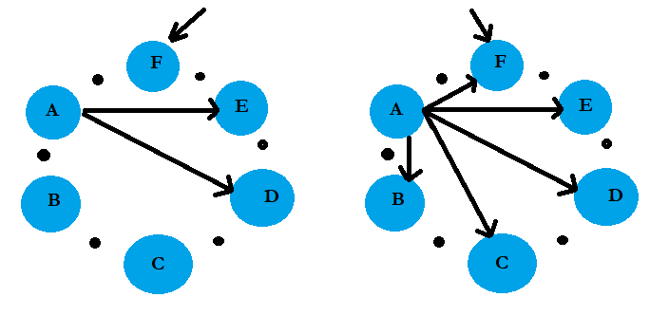

8.Create materialzed view
CREATE MATERIALIZED VIEW view_name AS
select Query;

Secondary Indexes and Materialized View

Materialized View Secondary Indexes
Integrates transparently with queries, no
Need To specify a second table
More powerful,can create flexible Layout

Two-Step query allows for seamless
integration with base table
Queries for view data in a single step

Can be used with Allow Filtering

To run and use ScyllaDB, you need to follow these general steps:

1.Download & Install

